

**Capstone Project Report**

**Report 1 – Project Introduction**

– Ho Chi Minh, September 2025 –

**Table of Contents**

I. Record of Changes 3

II. Project Introduction 4

1. Overview 4

1.1 Project Information 4

1.2 Project Team 4

2. Product Background 4

3. Existing Systems 5

3.1 Notion 5

3.2 Duolingo 5

3.3 Leetcode 5

4. Business Opportunity 5

5. Software Product Vision 6

6. Project Scope & Limitations 6

6.1 Major Features 6

6.2 Limitations & Exclusions 7

# I. Record of Changes

|  |  |  |  |
| --- | --- | --- | --- |
| Date | A* M, D | In charge | Change Description |
| 17/09/2025 | A* | Minh Anh | Initial document creation |
| 18/09/2025 | M | Minh Anh | Major features update and mindmap created |
|  |  |  |  |
|  |  |  |  |
|  |  |  |  |
|  |  |  |  |
|  |  |  |  |
|  |  |  |  |
|  |  |  |  |
|  |  |  |  |
|  |  |  |  |
|  |  |  |  |
|  |  |  |  |

*A - Added M - Modified D - Deleted

# II. Project Introduction

## 1. Overview

### 1.1 Project Information

* Project name: RogueLearn: An AI-Powered Platform for Gamifying Higher Education
* Project code: FA25SE050
* Group name: FA_CP_grp4_RogueLearn
* Software type: Web Application

### 1.2 Project Team

|  |  |  |  |
| --- | --- | --- | --- |
| **Full Name** | **Role** | **Email** | **Mobile** |
| Phạm Thanh Trí | Lecturer | tript9@fe.edu.vn | 0937359396 |
| Đỗ Phúc Thịnh | Lecturer | thinhdp2@fe.edu.vn | 0874088880 |
| Ưng Nguyễn Song Phúc | Leader | phucunsse183483@fpt.edu.vn | 0978299460 |
| Đặng Ngọc Thịnh An | Member | andntse183508@fpt.edu.vn | 0931137913 |
| Phạm Hoàng Minh Anh | Member | anhphmse183496@fpt.edu.vn | 0902864508 |
| Nguyễn Duy Tân | Member | tanndse183491@fpt.edu.vn | 0918790709 |
| Nguyễn Đình Dương | Member | duongndse183456@fpt.edu.vn | 0812954301 |

## 2. Product Background

University students often face significant challenges with motivation and connecting their current studies to future career goals. The lack of a clear, engaging pathway can lead to procrastination and anxiety.

RogueLearn addresses this by transforming the educational journey into an interactive RPG. It allows players to choose their academic curriculum as their "Route" (foundational quest line) and select a career specialization from roadmap.sh as their "Class" (supplementary career-focused content).

The system provides a structured, AI-powered curriculum-based "main quest line" where exams become "Boss Fights," and knowledge acquisition is visualized as a "Skill Tree."

Players can enhance their experience by uploading achievement documents and project portfolios to personalize their skill tree and arsenal management. The AI performs intelligent gap analysis between curriculum and career requirements, generating supplementary quests to bridge academic learning with industry needs.

This shows players exactly how their learning connects and contributes to their ultimate career goal. A companion browser extension further enhances this by automatically capturing relevant learning materials from the web, organizing them into the player's "Arsenal." This turns passive learning into an active and meaningful adventure, making studying more effective and building a foundation for a rich academic ecosystem involving lecturers, and peer groups.

## 3. Existing Systems

### 3.1 Notion

* Description: All-in-one workspace with a rich block editor, databases, and templates for organizing knowledge.
* Link: <https://www.notion.so/>
* System Actors: Individual students, teams.
* Key Features: Rich blocks, relations, tags, powerful search, web clipper.
* Pros: Polished UX, flexible organization, quick onboarding.
* Cons: Proprietary, limited offline-first behaviour, complex advanced features.
* Learnings/Adoption: Use Notion-like editor patterns; implement CRUD, tagging, filters, and linking to skills/quests.

### 3.2 Duolingo

* Description: Gamified language learning platform with strong progression loops.
* Link: <https://www.duolingo.com/>
* System Actors: Language learners.
* Key Features: XP, streaks, leagues, bite-sized lessons.
* Pros: Highly engaging gamification, clear progression.
* Cons: Gamification can overshadow depth, not academic-focused.
* Learnings/Adoption: Minimal gamification (XP, achievements) to support motivation; avoid heavy mechanics.

### 3.3 Leetcode

* Description: Competitive programming platforms for practice and contests.
* Link: <https://www.leetcode.com/>
* System Actors: Competitors, learners.
* Key Features: Timed challenges, scoring, leaderboards.
* Pros: Strong engagements, clear difficulty progression.
* Cons: Competitive focus may not fit curriculum; fairness concerns.
* Learnings/Adoption: Implement scoring and basic leaderboards.

## 4. Business Opportunity

The student learning market is crowded with single-purpose tools—note-taking apps, course platforms, and social communities—that fragment the learning experience across motivation, organization, and progress tracking. RogueLearn creates a cohesive, engaging layer on top of the existing academic environment by fusing gamified progression (Route, Class, Boss Fights, Skill Tree) with personal knowledge management (Arsenal) and lightweight collaboration (Party).

Environment of use:

* Individual university students, bootcamp learners, and self-study groups using a web application and companion browser extension.
* Campus and remote/hybrid learning contexts that require cross-device continuity and privacy-aware sharing.

Why RogueLearn is attractive:

* Integrates a student's curriculum (Route) and chosen specialization (Class) into a unified, visual progression with clear milestones and feedback loops.
* Connects personal notes (Arsenal) directly to skill nodes and quests, turning captured materials into actionable learning steps.
* Enables collaborative study via Party Stash while preserving data ownership and privacy boundaries.
* Provides AI-driven gap analysis between academic requirements and career demands to generate supplementary quests.

Problems not well solved today without RogueLearn:

* Connecting university coursework to real career paths in a personalized, visual, and motivating way.
* Turning fragmented notes and resources into structured learning artifacts linked to progression and assessments.
* Seamless capture from the browser into a structured Arsenal tied to skills and quests, rather than generic bookmarks.

Fit with market trends and strategic direction:

* AI-assisted personalization, micro-learning, and dynamic learning paths.
* Gamification as a proven engagement lever, applied thoughtfully to academic mastery rather than only habit loops.

## 5. Software Product Vision

For university students who want a clear, motivating way to plan and conquer their academic journey while connecting it to real career goals, RogueLearn is a gamified, AI-assisted learning platform that transforms curricula into quest lines, exams into Boss Fights, and knowledge into a visual Skill Tree. It unifies personal notes captured from the web (Arsenal), structured progression (Route and Class), and lightweight collaboration (Party) into a single experience across web app and browser extension.

Unlike generic note-taking tools, standalone course platforms, or unstructured social communities, RogueLearn integrates a student's own curriculum and captured materials into actionable quests with mastery tracking and AI-driven guidance. This reduces anxiety, increases engagement, and turns everyday study into a meaningful adventure—grounded in practical architectures, privacy-by-design, and an MVP-first scope that prioritizes core loops before advanced collaboration and analytics.

## 6. Project Scope & Limitations

### 6.1 Major Features

FE-01: Onboarding & academic data.

FE-02: AI curriculum & career alignment.

FE-03: Skill & stats foundation.

FE-04: Dashboard, skill tree & arsenal.

FE-05: Boss fights & leaderboards.

FE-06: Dynamic quest & notifications.

FE-07: Browser extension integration (FPTU & Arsenal).

FE-08: Party & collaboration (study groups).

FE-09: Meetings & summaries.

FE-10: Boss fights (Co-op).

FE-11: Guild management.

FE-12: Code battle & competitive events.

FE-13: Event management & administrative platform.

FE-14: Academic integration (FPTU, Quest memory & recovery).

FE-15: Admin-owned educational governance.

FE-16: Objective system, knowledge graph & rewards.

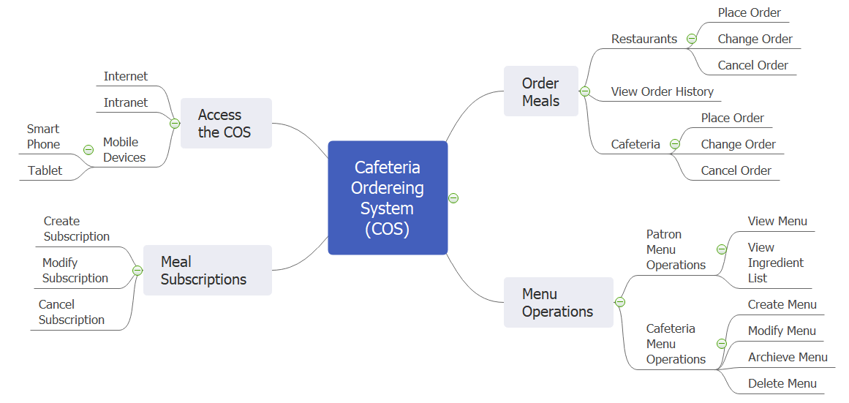

### 6.2 Limitations & Exclusions

LI-1: Payment and subscription features are excluded. No premium tiers, billing, or entitlement are implemented.

LI-2: Code battle events are free for all and not brackets tournaments.

LI-3: Browser extension does not record meetings; it is limited to web content capture and contextual assistance.

LI-4: Native mobile apps are out of scope.

LI-5: AI generation quality is best-effort. Confidence thresholds apply; manual override/resubmission may be required for low-confidence outputs

LI-6: Marketplace features for exchanging notes and in-game currency are out of scope.

LI-7: Primary support language is English; non-English documents may reduce AI accuracy and coverage.